

Job Advertisement Portal
Software Requirements Specification Document

COS5019-B Enterprise Pro

Team 17

Imaan Syedda UB 24001615
Zahra Shahzad UB 24000915
Danyaal Akhtar UB 24008876
Seif Ilyas UB 24004896
Ishaq Mahmood UB 24005604

Faculty of Management, Sciences and Engineering
School of Computing and Engineering

Table of Contents
1.Introduction
1.1 Document Purpose
1.2 Project overview
1.3 Scope of the Document
1.4 Related Documents
1.5 Definitions and Acronyms
1.6 Assumptions and Risks
2.Team Expertise
3. Rationale for Topic Choice
4. Literature Review
5. System Scope
5.1 In Scope Features
5.2 Out of Scope Features
5.3 Dependencies and Impacts
6. User Roles
7. Functional Requirements
7.1 Functional Requirements
7.2 Use Cases
7.3 Use Case Diagram
8. ER Diagram
9. Data Description
9.1 Users
9.2 Jobs
9.3 Applications
9.4 Contacts
9.5 Employer Profile
9.6 Subscription
9.7 Saved Jobs
9.8 Job Seeker Profile
10. Class Diagram
11. Interface Design and Navigation Structure
11.1 Total Pages
11.2 Navigation and Access Control
12. Payment Workflow
12.1 Payment Purpose
12.2 Payment Timing
12.3 Payment Implementation
13. Non-Functional Requirements
13.1 Usability
13.2 Performance
13.3 Security
13.4 Scalability
13.5 SEO
14. Work Plan
15. Legal, Social, Ethical and Professional Considerations
15.1 Legal
15.2 Social
15.3 Ethical
15.4 Professional Issues
16. Economic Considerations
17. Assumptions and Constraints
17.1 Assumptions
17.2 Constraints
18. Acceptance Criteria Summary
19. Tools and Technologies
20. Peer Review
21. Approval
22. GitHub Link
23. Agreement
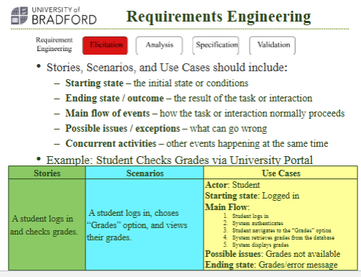

Introduction

Document Purpose
The purpose of this document is to define the functional and non-functional requirements for the requested software- the Job Advertisement Portal- from the industry client. Its purpose is to establish a clear and agreed understanding between developers and clients of the system requirements, to define clearly the different features of the software between the industry client and the development team prior to the implementation of the software. This is all to be done with the constraints and in accordance of the assessment brief.
This document will serve as the main specification for the industry client and the development team to explore and define the design of the software that will be evaluated in part A and part B of the project lifecycle, alongside the testing and iteration.

1.2 Project Overview
The Job Advertisement Portal will be a modern web based application that is designed to streamline and enhance the experience of creating jobs/ work opportunities, discovering them, and applying to them.
Logged and verified Jobseekers and Employers will be able to advertise and apply to jobs. Employers will be able to add requirements e.g “Education level needed- Bachelors Degree.” This is an example of a job that can be advertised, and once an employer accepts an application, the jobseeker will be sent an automated email regarding their application status. Employers will be able to view and respond to jobseekers applications.
All job posts will be displayed for public view on the main page/dashboard, with the option for the jobseeker to use location and discipline based filtering to ensure that the jobs they see is relevant to them. The system will incorporate user verification to ensure safety and simulated and secure payment workflows (not real payments). Jobseekers will be able to leave reviews and ratings on employers, and these will also be publicly available to view and make a decision. An administrative portal will be available for admins, including content management and efficient functionality. The platform will be designed with Search Engine Optimisation effectively, alongside data security and scalability in mind as core principles to creating the software. Jobseekers will be able to p[ay for a premium subscription that allows for their applications to be viewed at the top of the list by employers.

1.3 Scope of the Document
This document covers the full specification of the Job Advertisement Portal including functional requirements, non-functional requirements, user roles, payment simulation workflows, system pages, and constraints. This document does not cover implementation code, final UI designs, or real-world deployment beyond what is required in the assessment brief.

1.4 Related Documents
This document is supported by the client brief, the Enterprise Pro assessment brief, any weekly lab guidance, and team documentation such as meeting notes, story cards, and early prototypes.

1.5 Definitions and Acronyms
-SEO - Search Engine Optimisation
-CMS - Content Management System
-UI - User Interface
-UOB - University of Bradford
-RBAC - Role Based Access Control
-SRS - Software Requirements Specification

1.6 Assumptions and Risks
Assumptions are listed in Section 17.
Risks that could affect the project include:
1.6.1 Changes in client expectations during development which could cause scope creep.
1.6.2 Limited development time due to the academic schedule.
1.6.3 Third-party services (email / verification / sandbox payments) being unreliable or changing behaviour.
1.6.4 Testing limitations due to not using real payments and real verification environments.

2. Team Expertise
Team 17 consists of five Software Engineering students from the University of Bradford, each contributing different skills relevant to the development of the Job Advertisement Portal. The project requires a combination of software engineering knowledge, web development skills, documentation abilities, and teamwork.
Each team member contributes to similar areas of the system development process including frontend development, backend implementation, database design, documentation, and project management.
Team Member | Role | Expertise
Danyaal Akhtar | Frontend Development & Backend API Integration & Testing | Working on a few pages in the frontend and working on the backend integration of those pages
Seif Ilyas | Documentation & Frontend Development & Backend API Integration | Working on majority of the documentation whilst also maintaining the GitHub and keeping up with the functionality of the code
Imaan Syedda | Frontend Development & Backend API Integration & Testing | Working on a few pages in the frontend and working on the backend integration of those pages
Zahra Shahzad | Documentation & Frontend Development & Backend API Integration & Testing | Working on a few pages in the frontend and working on the backend integration of those pages and also working on the UI Design
Ishaq Mahmood | Frontend Development & Backend API Integration & Testing | Working on a few pages in the frontend and working on the backend integration of those pages

The collaboration between team members ensures that both technical development and documentation tasks are completed effectively, while also allowing the team to apply software engineering methodologies learned during the course.

3. Rationale for Topic Choice
We chose the Job Advertisement Portal project because it allows our group to create a realistic and useful platform that solves a real world problem. The portal helps individuals advertise services or job requirements securely and locally, which is important in today’s digital economy. This project requires both technical and enterprise skills which is why we chose this for our coursework. As a group, we felt this idea was scalable and suitable for building a professional full stack website.

Our group’s skills match the project requirements well. Ishaq is skilled in frontend development, helping to build responsive and interactive user interfaces. Zahra specialises in UI design and frontend work, ensuring the website is visually appealing and user friendly. Danyaal has experience in both frontend and backend development, allowing him to connect the user interface with server side logic. Imaan is strong in data entry, backend development and security, which is essential for handling user information, authentication and payments securely. Seif is responsible for GitHub repository management, project organisation, documentation and backend development, ensuring smooth teamwork and version control.

By combining our individual strengths, we can work together effectively to develop a complete full stack solution. The frontend team will focus on responsive design, job listings and user interaction, while the backend team will handle authentication, data storage, security and admin features. With clear roles and using GitHub effectively, we can manage the project efficiently and meet all requirements.

4. Literature Review
Job advertisement portals have become a fundamental component of modern recruitment processes. Several existing platforms provide similar services, offering job listings, employer profiles, and application management systems.
One widely used platform is LinkedIn Jobs, which integrates professional networking with job search functionality. LinkedIn allows employers to advertise job opportunities while enabling users to apply directly through their professional profiles.
Another major platform is Indeed, which acts as a job aggregation service. Indeed collects job postings from multiple sources and provides search and filtering tools to help users find relevant opportunities.
Glassdoor is another platform that combines job listings with company reviews, allowing users to gain insight into company culture, salaries, and employee experiences.
While these platforms offer advanced features and global job listings, the Job Advertisement Portal developed in this project focuses on a simplified and academic implementation. The system is designed to simulate real-world job platform functionalities such as job posting, job searching, and application management while incorporating simulated payment systems and role-based access control.
The proposed system aims to replicate core features of professional job portals while remaining manageable within the scope of an academic software engineering project

5. System Scope

5.1 In-Scope Features
In accordance to the client brief, there will be various core features that are in the scope of the requirements. These are the following features, as stated below.
    - User registration and secure authentication
    - Jobseekers application pages
    - Live support chat
    - Verified user accounts
    - Job advertisement posting
    - Public job listings visible on the main page
    - Job categories and detailed job pages
    - Search, filtering, and sorting of job listings
    - Location-based filtering of jobs
    - User profile creation and management
    - Secure checkout workflow for premium subscription (sandbox)
    - Guest checkout functionality
    - Employer reviews and rating system
    - Admin portal for moderation and system management
    - Content Management System ,including: theme and banner management ,blog or news section and option to add student discounts
    - Customer support via contact forms
    - Notifications via email
    - Search Engine Optimisation, including SEO-friendly URLs, sitemap generation and meta tags.
    - Responsive design for desktop and mobile devices
    - Scalable system architecture to support future enhancement

Out-of-Scope Features
The following features will be explicitly excluded from the software, as they are not mentioned/ advised against in the client brief and the assessment brief.
    - Real- world financial payment processing
    - Native mobile applications
    - Legal contract enforcement
    - AI-based job matching or recommendation systems

Dependencies and Impacts
System/Software | Type | Description | Risk/Mitigation
Email Server/Email API | Dependency | Sends Application status updates and notifications to users. | Show in System notification as backup alongside email.
Database (SQL) | Dependency | Stores users, jobs, applications, reviews, payment status, logins | Data Integrity issues- use validation and constraints- using hashing
User Account verification | Dependency | Verify users and accounts | Verification may fail or not be accurate- mitigated by report feature for suspicious activity.
Sandbox (mock) payments | Dependency | Limited realism- not completely real no money in use to keep track of | Clear sandbox labelling and test cases

6. User Roles

6.1 Guest User
A guest user is someone who is an unregistered user to the web platform. This could be someone looking for jobs online who came across the website, or someone who simply not made an account yet. Below are a few points of what guest users can do - without having an account. Guest users can:
    - View job listings that have been posted
    - Search and filter job advertisements using location and discipline filters
    - View detailed job information that has been posted
    - Register their login with an account

Registered Jobseeker
A registered user is also a user who uses the web application, but they have already registered with an account, so they have more opportunities and permissions to do more things on the job advertisement portal. The actions that can be carried out by registered users are listed below. Registered users can:
    - View job advertisements
    - Browse, search, and filter job listings
    - Apply for jobs
    - Manage personal profile information
    - Leave reviews and ratings
    - Receive system notifications via email

Registered Employer
A registered employer is also a user who uses the web application, but they have already registered with an account, so they have more opportunities and permissions to do more things on the job advertisement portal. The actions that can be carried out by registered users are listed below. Registered users can:
    - Post job advertisements
    - Accept or respond to job applications
    - Manage Company profile information
    - Manage job listings
    - View reviews and ratings after job completion
    - Receive system notifications via email

Administrator
An administrator is someone who manages and moderates the system. Administrators can:
    - Approve, edit, or remove job listings
    - Verify, manage, or suspend users
    - Moderate reviews and ratings
    - Manage CMS content (banners, discounts)
    - Access the admin dashboard
Administrative access will be provided via a dedicated admin login page that will be accessed through a direct URL, for example /admin/login and will be secured using role based access control.
7. Functional Requirements

7.1 Functional Requirements

The system shall support the following functional requirements:
  - The system shall allow users to register an account.
  - The system shall allow users to log in and log out securely.
  - The system shall support user verification mechanisms.
  - The system shall allow registered employers to post job advertisements
  - The system shall display all job listings on the main listings page.
  - The system shall allow users to view detailed job information.
  - The system shall allow users to search, filter, and sort job listings.
  - The system shall support location based filtering of job listings.
  - The system shall allow users to manage their profiles.
  - The system shall provide a checkout process for premium subscription.
  - The system shall support simulated payments.(sandbox)
  - The system shall charge employers a monthly fee to use the job advertisement portal.
  - The system shall confirm payment completion and update job profile.
  - The system shall allow users to leave reviews and ratings on employer profiles
  - The system shall send notifications via email
  - The system shall provide a customer support contact mechanism.(AI chat)
  - The system shall provide an admin portal for moderation and management.
  - The system shall support CMS functionality- banners, discounts
  - The system shall support SEO features such as Seo friendly URLs.

7.2 Use Cases
Use Case ID | UC-1
Use Case Name | View Job Listings
Primary Actor | Guest User/ Registered Job Seeker
Trigger | Users open the job listings page
Pre-Conditions | none
Post-Conditions | job listings are displayed
Main success scenario | User navigates to the job listings page  System retrieves job data  System displays job listings
Alternative Flows | If no job exists, the system displays a “no jobs available”
Priority | High
Use Case ID | UC-2
Use Case Name | Apply for a job
Primary Actor | Registered Job Seeker
Trigger | Users click “apply”
Pre-Conditions | User logged in
Post-Conditions | Application is submitted
Main success scenario | User open job details  Clicks apply  System validates account  Application is stored  Employer receives notification
Alternative Flows | If User is not logged in, redirect to login page
Priority | High
Use Case ID | UC-3
Use Case Name | Post job advertisement
Primary Actor | Registered Employer
Trigger | Employer submits job form
Pre-Conditions | Employer logged in and subscribed
Post-Conditions | Job is published
Main success scenario | Employer enters job details  Submits form  System validates fields  Job is stored and displayed
Alternative Flows | If Employer is not logged in, redirect to login page
Priority | High
Use Case ID | UC-4
Use Case Name | Register Account
Primary Actor | Guest User
Trigger | User clicks “Register”
Pre-Conditions | None
Post-Conditions | Account is created or pending verification
Main success scenario | User opens the registration page  User enters details  System validates the inputs  System creates the account  System sends a verification email
Alternative Flows | If the email is already in use the system displays “Email is already registered”
Priority | High
Use Case ID | UC-5
Use Case Name | Login
Primary Actor | Registered Employer, Registered Job Seeker, Administrator
Trigger | User clicks “Login”
Pre-Conditions | User already has an account
Post-Conditions | User is logged into the system
Main success scenario | User opens the login page  User enters email and password  System validates credentials  System starts a session  System redirects a user to the correct dashboard/homepage
Alternative Flows | If credentials are incorrect the system displays “invalid login details”
Priority | High
Use Case ID | UC-6
Use Case Name | Logout
Primary Actor | Registered Employer, Registered Job Seeker, Administrator
Trigger | User Clicks “logout”
Pre-Conditions | User is logged in
Post-Conditions | Session ends and user is logged out
Main success scenario | User clicks logout  System terminates the session  System redirects user to the landing page
Alternative Flows | If session already expired, system redirects user to the login page
Priority | High
Use Case ID | UC-7
Use Case Name | Filter Jobs
Primary Actor | Registered Job Seeker, Guest User
Trigger | User selects filter options
Pre-Conditions | Job listings exist
Post-Conditions | Filtered job results are displayed
Main success scenario | User selects the filter options  System applies the selected features  System updates the list
Alternative Flows | If filtered results are empty, system displays “no jobs match your filters”
Priority | Medium
Use Case ID | UC-8
Use Case Name | Search Job Listings
Primary Actor | Registered Job Seeker, Guest User
Trigger | User enters a keyword in the search bar and clicks “Search”
Pre-Conditions | Job listings exists
Post-Conditions | Matching job listings are displayed
Main success scenario | User opens the job listings page  User enters keyword  System searches job data  System displays matching listings
Alternative Flows | If no results match, system displays “no jobs found”
Priority | High
Use Case ID | UC-9
Use Case Name | View job details
Primary Actor | Guest User/ Registered Job Seeker
Trigger | User clicks on a job listing
Pre-Conditions | Job listing exists
Post-Conditions | Full job details are displayed
Main success scenario | User selects a job from the listings  System retrieves full job information  System displays job details page
Alternative Flows | If job has been removed, system displays “this job is no longer available” and returns to job listings page
Priority | High
Use Case ID | UC-10
Use Case Name | Manage Profile
Primary Actor | Registered Job Seeker
Trigger | User clicks edit profile
Pre-Conditions | User logged in
Post-Conditions | Profile changes are saved
Main success scenario | User opens profile page  User edits details  System validates inputs  System saves updated profile  System displays success message
Alternative Flows | If input is invalid, system highlights errors and does not save changes
Priority | Medium
Use Case ID | UC-11
Use Case Name | Purchase premium subscription
Primary Actor | Registered Job Seeker
Trigger | User clicks premium button and confirms payment
Pre-Conditions | User logged in
Post-Conditions | Premium status is activated
Main success scenario | User opens premium page  User selects subscription option  System sends user to sandbox checkout  Payment is processed  System updates account to premium  System displays confirmation
Alternative Flows | If payment fails, system displays payment failed and premium is not activated
Priority | High
Use Case ID | UC-12
Use Case Name | Pay employer monthly subscription
Primary Actor | Registered Employer
Trigger | Employer clicks subscribe and confirms payment
Pre-Conditions | Employer logged in
Post-Conditions | Employer subscription is active
Main success scenario | Employer opens subscription page  Employer selects plan  System sends employer to sandbox checkout  Payment is processed  System activates employer subscription  System displays confirmation
Alternative Flows | If payment fails, system displays payment failed and subscription is not activated
Priority | High
Use Case ID | UC-14
Use Case Name | Manage company profile
Primary Actor | Registered Employer
Trigger | Employer clicks company profile
Pre-Conditions | Employer logged in
Post-Conditions | Company profile is updated
Main success scenario | Employer opens company profile page  Employer edits company details  System validates inputs  System saves updated company profile  System displays success message
Alternative Flows | If input is invalid, system highlights errors and does not save changes
Priority | Medium
Use Case ID | UC-15
Use Case Name | Manage job listings
Primary Actor | Registered Employer
Trigger | Employer selects job listing and clicks edit/delete
Pre-Conditions | Employer logged in  Job listing exists
Post-Conditions | Selected job listing is updated
Main success scenario | Employer opens job listings  Employer selects a listing  Employer chooses to edit/delete  System validates permission  System updates the job listing  System confirms changes
Alternative Flows | If employer does not own the listing, system displays something like unauthorised action
Priority | High
Use Case ID | UC-16
Use Case Name | View Applications
Primary Actor | Registered Employer
Trigger | Employer clicks applications on a posted job
Pre-Conditions | Employer logged in  Has posted jobs
Post-Conditions | Applications are displayed
Main success scenario | Employer opens a job listing management page  Employer selects a job listing  System retrieves applications for that job  System displays applicant list
Alternative Flows | If no applications exist system displays no applications received yet
Priority | High
Use Case ID | UC-17
Use Case Name | Accept/ Reject application
Primary Actor | Registered Employer
Trigger | Employer clicks accept or reject on an application
Pre-Conditions | Employer logged in and applications exist
Post-Conditions | Application status is updated and applicant is notified
Main success scenario | Employer opens applications list  Employer selects applicant  Employer clicks accept/ reject  System updates application status  System notifies job seeker
Alternative Flows | If system fails to update status, system displays unable to update application status
Priority | High
Use Case ID | UC-18
Use Case Name | Leave Review & Rating
Primary Actor | Registered Job Seeker
Trigger | User submits a review form
Pre-Conditions | User logged in
Post-Conditions | Review is stored and displayed
Main success scenario | User opens employer profile page  User selects leave review  User enters review and rating  System validates input  System stores the review  System displays confirmation
Alternative Flows | If review violates the rules the system will display the review cannot be submitted
Priority | Medium
Use Case ID | UC-19
Use Case Name | Contact support
Primary Actor | Guest user, Registered Job Seeker, Registered Employer
Trigger | User clicks support or help
Pre-Conditions | none
Post-Conditions | User receives support response or message is submitted
Main success scenario | User opens support page  User chooses ai chat or contact form  User submits question/message  System provides response or logs the support request  System displays confirmation
Alternative Flows | If support service is unavailable system display support is currently unavailable
Priority | Low
Use Case ID | UC-20
Use Case Name | Admin moderate job listings
Primary Actor | Administrator
Trigger | Admin selects a job listing for moderation
Pre-Conditions | Admin logged in
Post-Conditions | Job listing is approved, edited or removed
Main success scenario | Admin opens admin dashboard  Admin views pending/flagged job listings  Admin selects a listing  Admin approves/edits/removes listing  System updates job listing status  System confirms the action
Alternative Flows | If listing is already removed, system displays listing not found
Priority | High
Use Case ID | UC-21
Use Case Name | Admin manage users
Primary Actor | Administrator
Trigger | Admin selects user account
Pre-Conditions | Admin logged in
Post-Conditions | User account status is updated
Main success scenario | Admin opens admin dashboard  Admin searches/selects user  Admin chooses to either verify suspend or remove  System updates the user status  System confirms the action
Alternative Flows | If admin action fails, system displays “unable to update user status”
Priority | High
Use Case ID | UC-22
Use Case Name | Admin moderate reviews and ratings
Primary Actor | Administrator
Trigger | Admin views submitted reviews
Pre-Conditions | Admin logged  Reviews exist
Post-Conditions | Review is approved or removed
Main success scenario | Admin opens admin dashboard  Admin views reviews list  Admin selects a review  Admin approves or removes a review  System updates review status  System confirms the action
Alternative Flows | If review is already deleted, system displays “review not found”
Priority | Medium
Use Case ID | UC-23
Use Case Name | Manage CMS content
Primary Actor | Administrator
Trigger | Admin clicks CMS section
Pre-Conditions | Admin logged
Post-Conditions | CMS content is updated and displayed on the website
Main success scenario | Admin opens CMS page  Admin selects content type  Admin edits content  System validates input  System saves changes  System updates website content
Alternative Flows | If content save fails, system displays unable to save changes
Priority | Medium

7.3 Use Case Diagram
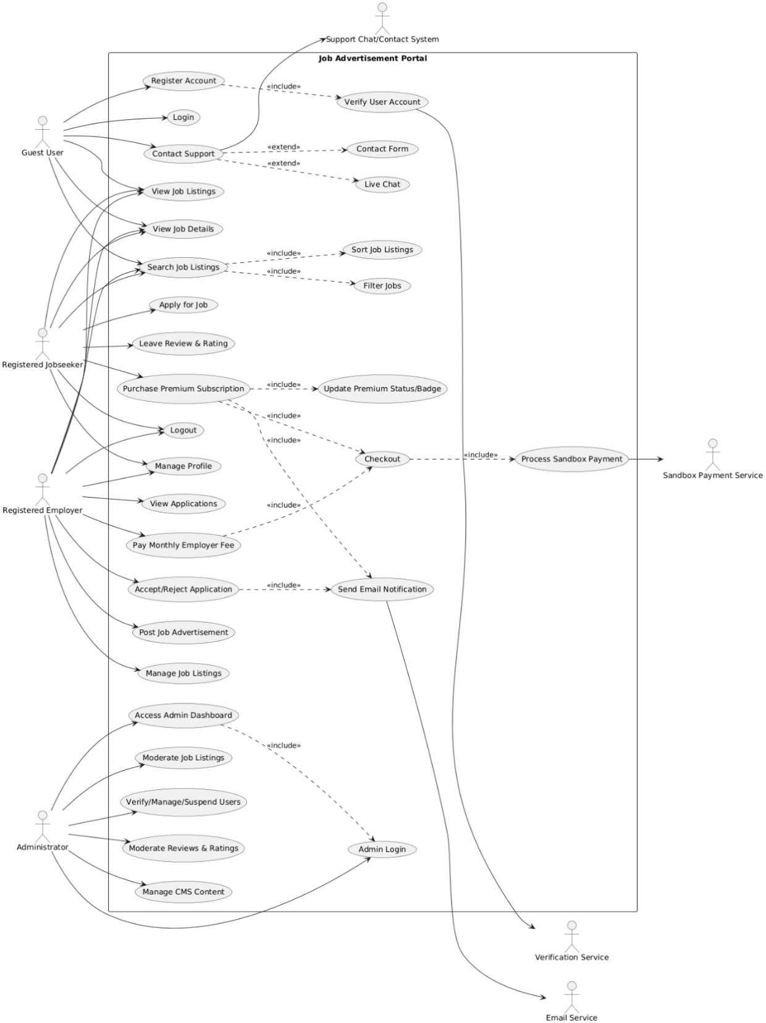

8. ER Diagram
The ER Diagram shows the database structure of the Job Advertisement Portal. The USERS table acts as the central entity and connects to profile, job, application, saved job, and subscription data. This structure supports the main platform functions including job posting, job applications, profile management, saved jobs, and subscription handling
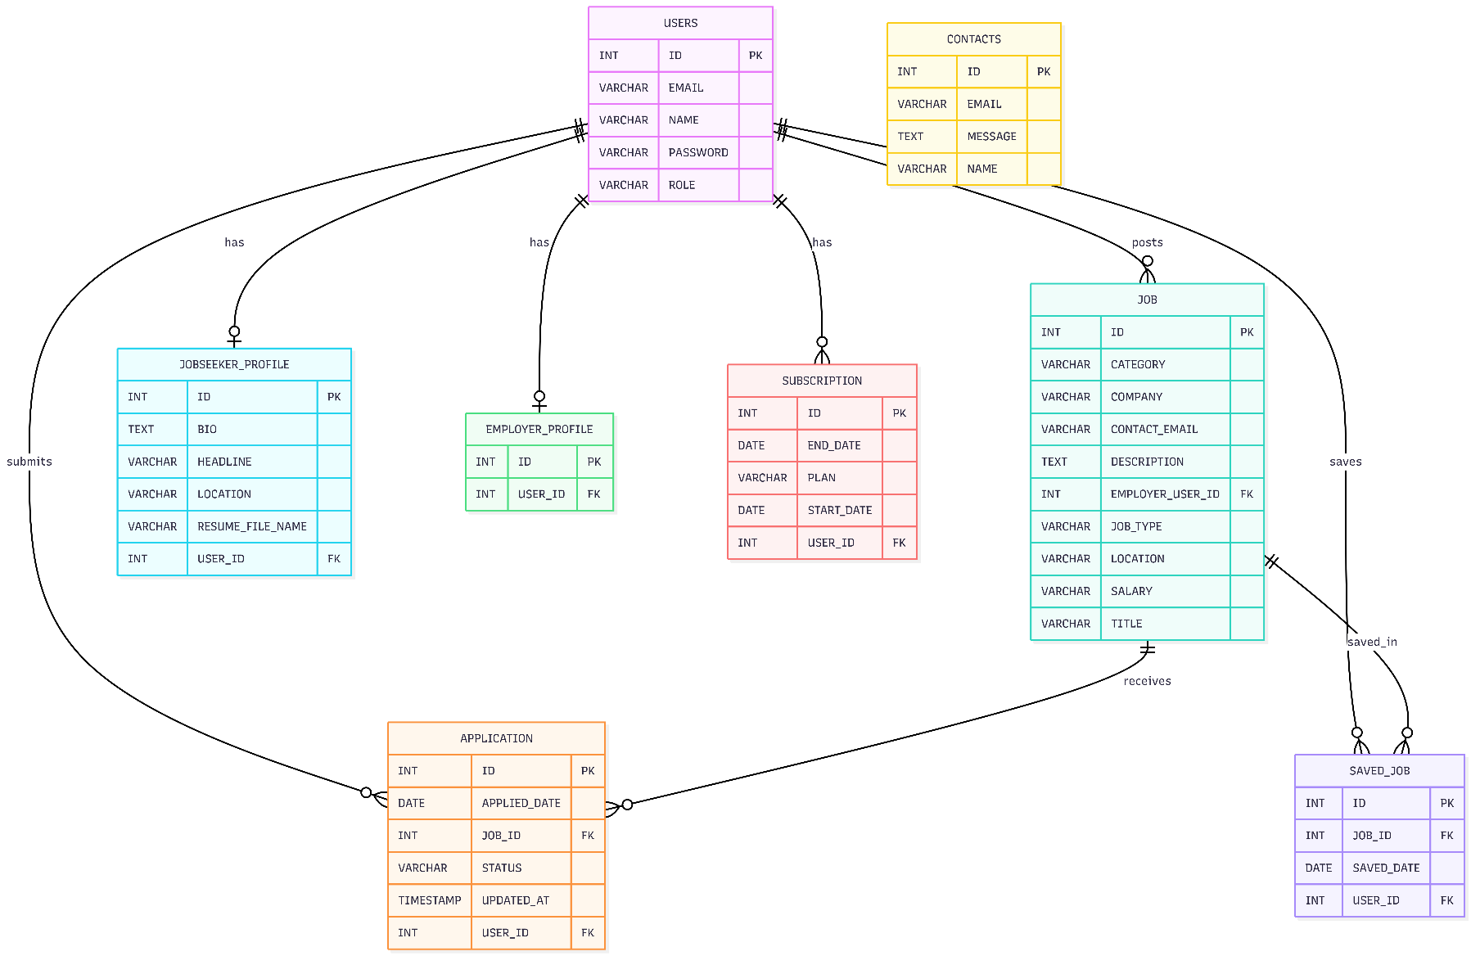

9. Data Description

9.1 Users
The USERS table stores the main account information for all users of the system. This includes jobseekers, employers, and administrators. Each user has a unique identifier and a role which determines what actions they are allowed to perform within the portal
Field | Description
ID | Unique identifier for each user
EMAIL | User email address used for login
NAME | Full name of the user
PASSWORD | User password stored in the system
ROLE | Identifies whether the user is a jobseeker, employer, or administrator

9.2 Jobs
The JOB table stores all job advertisements posted within the portal. Each job record contains details about the role being offered, the company, location, type of job, and salary information.
Field | Description
ID | Unique identifier for each job listing
CATEGORY | Category of the job, such as Software Engineering or Data / AI
COMPANY | Name of the company posting the job
CONTACT_EMAIL | Employer contact email for the job
DESCRIPTION | Description of the role and responsibilities
EMPLOYER_USER_ID | References the employer who posted the job
JOB_TYPE | Type of role, such as Full-time, Part-time, or Internship
LOCATION | Job location
SALARY | Salary or salary range
TITLE | Title of the job advertisement

9.3 Applications
The APPLICATION table stores job applications submitted by users. It links jobseekers to the jobs they have applied for and tracks the status of each application.
Field | Description
ID | Unique identifier for each application
APPLIED_DATE | Date the application was submitted
JOB_ID | References the job being applied for
STATUS | Current application status, such as pending, accepted, or rejected
UPDATED_AT | Date the application record was last updated
USER_ID | References the user who submitted the application

9.4 Contacts
The CONTACTS table stores messages submitted through the contact or support page of the system. It allows users or visitors to send enquiries directly through the portal.
Field | Description
ID | Unique identifier for each contact message
EMAIL | Email address of the person submitting the message
MESSAGE | Content of the message
NAME | Name of the sender

9.5 Employer Profile
The EMPLOYER_PROFILE table stores additional information related to employer accounts. It is used to separate employer-specific details from the general user account stored in the USERS table.
Field | Description
ID | Unique identifier for each employer profile
USER_ID | References the employer user account
Other employer fields | Employer-related profile information stored by the system

9.6 Subscriptions

The SUBSCRIPTION table stores subscription records for users who choose a subscription plan within the platform. This supports premium functionality and simulated payment-related workflows.
Field | Description
ID | Unique identifier for each subscription record
END_DATE | Date the subscription ends
PLAN | Name or type of subscription plan
START_DATE | Date the subscription begins
USER_ID | References the subscribed user

9.7 Saved Jobs
The SAVED_JOB table stores jobs that users choose to save for later viewing. This supports a better user experience by allowing jobseekers to keep track of interesting opportunities.
Field | Description
ID | Unique identifier for each saved job record
JOB_ID | References the saved job
SAVED_DATE | Date the job was saved
USER_ID | References the user who saved the job

9.8 Job Seeker Profile
The JOBSEEKER_PROFILE table stores additional profile information for registered jobseekers. This information helps personalise the user account and supports job applications.
Field | Description
ID | Unique identifier for each jobseeker profile
BIO | Short biography of the user
HEADLINE | Profile headline or short introduction
LOCATION | User location
RESUME_FILE_NAME | Name of the uploaded CV or resume file
USER_ID | References the user account linked to the profile
The database is designed so that the USERS table acts as the central entity. User accounts are linked to jobseeker profiles, employer profiles, applications, saved jobs, and subscriptions. Employer users can create job advertisements, while jobseeker users can apply for jobs and save jobs. This relational structure ensures that the system supports the key functions of the Job Advertisement Portal in a consistent and organised way.

10. Class Diagram
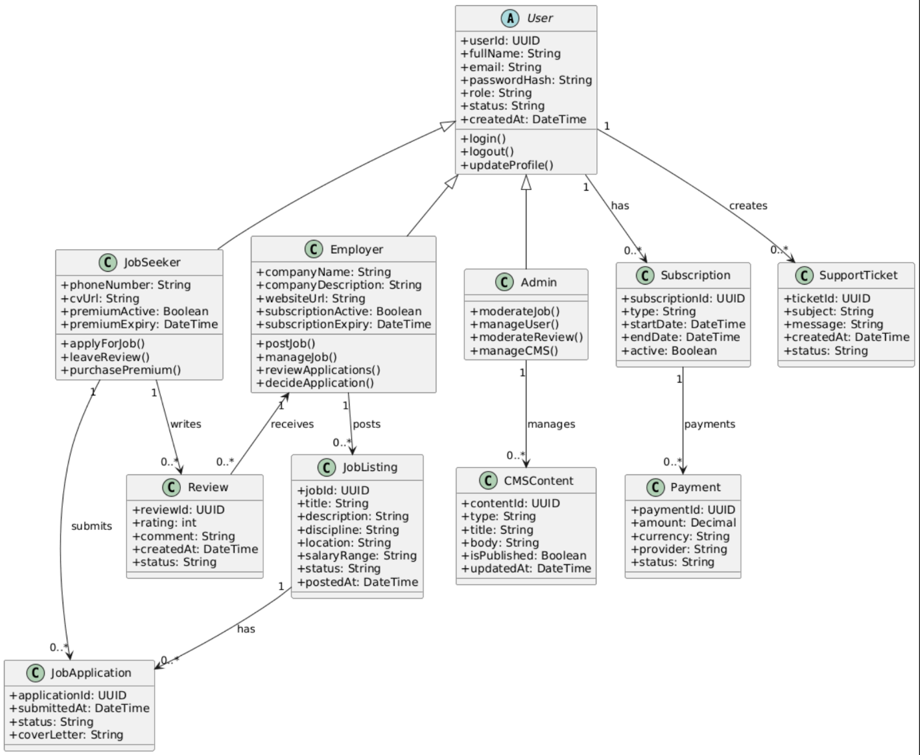

11. Interface Design and Navigation Structure

11.1 Total Pages
The system is structured using a page based navigation model to ensure clarity and usability, while also keeping logical separation of functionality in mind. Each page has been designed with a specific purpose, supporting the overall user journey from job discovery to job completion and payment confirmation. This structure allows users to easily access relevant features based on their location or search, while also supporting scalability and maintainability by clearly defining the responsibilities of each page within the system. The pages to be implemented are listed below.

Public Pages (10)
    - Home Page
    - Job Listings Page
    - Job Details Page
    - User Registration Page
    - User/Employer Login Page
    - User/employer Profile Page
    - Post Job Page
    - Checkout / Payment Page
    - Contact / Support Page
    - Employer Registration page

Admin Pages (2)
    - Admin Login Page
    - Admin Dashboard

Navigation and Access Control
Effective and intuitive navigation will be designed to adapt based on the users role and their authentication status. This means that public pages will be accessible without login, while other user specific pages may require a login or more information to access. This is because of the role based access control that will be implemented. Some implementations of this are listed below.
    - Public pages are accessible to all users
    - User-specific pages require authentication
    - Admin pages require role-based authorisation.
    - Admin pages are not linked from public navigation menus

12. Payment Workflow

12.1 Payment Purpose
The payment functionality will exist to confirm premium subscription purchase, and will be developed to simulate real world transactional payment workflows. Due to the assessment brief the payment workflow in this software will be in an academic context and will only use mock and sandbox payment workflows to ensure professionalism and security.
In addition, the simulated payment process will be designed to reflect common industry practices, payment selection, and transaction completion. No real financial data will be collected or stored, ensuring compliance with data protection and security principles. This approach allows the system to demonstrate a realistic end to end checkout experience while remaining appropriate for an academic environment and aligning with the requirements outlined in the assessment brief.

12.2 Payment Timing
When will payment be confirmed? When will it be required? In accordance to the client brief, payment will only be required when Jobseekers opts in to use premium subscription or an Employer wishes to access the job posting features. Below are points clearly outlining the payment timings.
    - Monthly Payment is required from employers to post a job.
    - Monthly Payment is required from jobseekers if they wish to use premium features.
    - Payment confirmation from the employer allows them to post jobs and access all employer features
    - Payment confirmation from the jobseeker allows their applications to be prioritised and viewed quicker by employers and is represented by a small badge on their profile.

Payment Implementation
The implementation of payments within the system will utilise mock and sandbox based workflows, this is to ensure that it effectively and accurately simulates real world payment transactions while also keeping the system secure. The aim is to replicate selecting a payment method, confirming the transaction, and the updating of the accounts features accordingly like a real word situation.
    - Payments are simulated using sandbox or mock methods, not real money.
    - No real financial transactions occur during payments.
    - Payment options include mock representations of bank transfer.

13. Non-Functional Requirements

13.1 Usability

The system will be designed with usability as a core principle. This is to ensure that users can interact with the platform efficiently regardless of their tech skills (with the assumptions in mind mentioned later below.) This would call for an intuitive and efficient platform, which is what we aim to develop; as the portal is intended for a wide range of users with varying technical experiences. The graphical user interface must be clear, intuitive, and aesthetically pleasing. Usability requirements are listed below.
    - The system shall provide a modern, user-friendly interface
    - The system shall be fully responsive and mobile-friendly
    - Navigation shall be intuitive and accessible

Performance
System performance is a critical requirement, as users expect fast and responsive interactions when browsing job listings or managing their accounts. We aim to create the platform so that it must be capable of handling typical user activity without noticeable delays, even as the number of users increases.
    - Pages shall load within acceptable time limits under normal usage conditions

Security
Security will be implanted carefully and effectively into the software. It is a fundamental requirement due to the software’s nature of handling user data like account logins and passwords. The system will be able to protect user information from unauthorised access and ensure that common security vulnerabilities are dealt with. Some security implementations are listed below.
    - Passwords shall be securely hashed and stored.
    - User and transaction data will be protected.
    - Input validation will be implemented to prevent common attacks like SQL insertion.

Scalability
The system will be designed with scalability in mind to support future growth and feature expansion of the software with ease and efficiency. As the number of users, job listings, and interactions will increase, the architecture should allow the system to continue functioning effectively without requiring major redesign. Some scalability implementations are listed below.
    - The system will be able to support a large number of concurrent users
    - The system architecture will be able to allow new features to be added with minimal redesign in the software.

SEO
Search engine optimisation will be included in the software to ensure that multiple publicly accessible pages are easily discoverable by search engines- like job listings and blog content. Implementing SEO will improve the visibility of the platform and it aligns with modern web development standards. Below a few SEO implementations are listed.
    - SEO friendly URLs shall be used
    - Meta tags shall be implemented
    - Sitemap generation shall be supported

14. Work Plan (Gantt Chart)
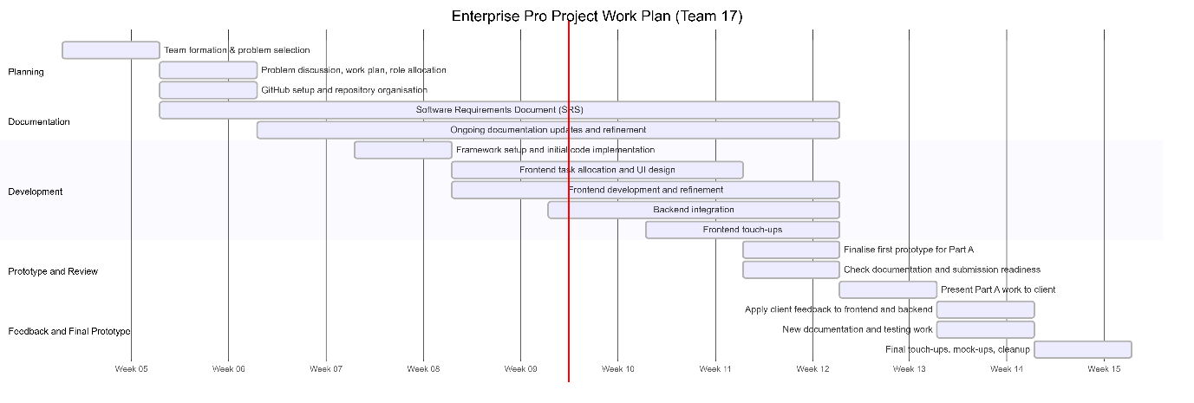
The development of the Job Advertisement Portal followed an iterative and overlapping development plan across eleven weeks. Early stages focused on team formation, project planning, and requirements documentation. Development began with framework setup and initial coding before progressing into frontend development and backend integration. Documentation continued alongside development until the completion of the first prototype. Following the prototype demonstration to the client, feedback was incorporated and the system was further refined and polished.

14.Legal, Social, Ethical and Professional Considerations
Creating a job advertisement portal comes with many challenges, with the problems being either legal, social, ethical or professional issues. These issues need to be addressed as they be risk factors once the portal has been developed.

14.1 Legal
A variety of legal issues can arise when creating a user-based interface, one being privacy, specifically the UK General Data Protection Regulation (UK GDPR) law which is adhered to by the UK since 2018. This law ensures that user data such as passwords are kept adequately and handled with appropriate security measures. Additionally, stronger protection is needed for sensitive information like a person’s race, ethnic background, health, etc. Furthermore, this also links to the Equality Act which must also consider individuals who may be at an advantage/disadvantage at getting hired by recruiters due to their ethnic background, race, gender, etc.
When using third party databases, or API’s, the users must be notified of the third-party organisation. This can be via terms and conditions when signing up. The website must also be transparent with what data is sent and this data needs to be minimal.

14.2 Social
One social issue which needs to be taken into consideration is job posting/regulation. More specifically, jobs need to be monitored by an admin as the jobs can not exceed the deadline date, misleading descriptions, scam jobs, etc. as this can cause issues to jobseekers. Admins can also regulate jobs by making sure a good standard is kept by the company who is posting jobs by implementing a rating system. This system can allow all types of users to see this universal rating as well as written reviews being available to the public.

14.3 Ethical
Several ethical issues can become a problem when dealing with a website which requires sensitive data from a user. More precisely, the user needs to be told explicitly about how their data may be used, shared to and stored. If not done correctly, this is a breach of privacy and can risk the user’s data being used for malicious intent. The user should also be able to delete their account without their details being saved as the data being saved further increases the risk of the data being misused.
An ethical concern on behalf of the employer side is jobs being misleading and inaccurate. For example, a job listing may be advertised with a misleading job description. As a result, jobseekers may apply but not reach the full demands of what is being advertised. To challenge this, admin users will be tasked with monitoring job postings as well as a chat bot being implemented allowing for jobseekers to explain their issues and make their frustrations known. Another way this can be challenged is making business have a verification process or paying to use the services of the website.
Another ethical issue regarding candidate filtering is also addressed. When jobseekers apply for a job posting, the order in which the employer will see the applicants is a first come first serve basis as well as a premium user being first. This is written as one of the benefits of the premium subscription for a job seeker. For many people candidate filtering becomes an ethical issue when certain demographics are more unseen for certain jobs.

14.4 Professional Issues
The main professional issue regarding a website is maintaining the website. More specifically, the website must be easy to use, navigate and secure. Having a website which fails to complete the 3 listed will cause issues for all users of the website. Having a website which has poor usability will discourage users from trying to use the website as well as navigation of the website not allowing them to access key features like their favourited jobs, viewing their profile, etc. Security is even more important than the last 2 as a job portal will handle a user’s CV which contains very sensitive data. These standards need to be upheld with the development of this project and the maintenance of it.

16. Economic Considerations
Although the Job Advertisement Portal is being developed as an academic project, it also reflects the economic aspects of a real-world web platform. A live version of this system would involve both development costs and running costs, while also offering possible revenue opportunities.
A job advertisement portal has economic value because it creates a digital space where employers and jobseekers can connect efficiently. Employers benefit from advertising roles and receiving applications in one place, while jobseekers benefit from easier access to opportunities. This creates a system that could be valuable both commercially and socially if developed further.

17. Assumptions and Constraints

17.1 Assumptions
The system will be developed with the assumption that users have access to a modern web browser and a stable internet connection. It is also assumed that users possess basic web navigation skills, allowing them to interact with common interface elements such as forms, menus, and buttons without guidance. The assumptions are stated clearly below.
    - Users have access to a modern web browser and internet connection
    - Users possess basic web navigation skills

Constraints
The development of the system is constrained by the academic nature of the project and the fixed project timeline defined by the module and assessment brief. As a result, certain features such as real-world payment processing are intentionally excluded, and simulated workflows are used instead. These constraints ensure that the system remains appropriate for educational purposes while still demonstrating professional software engineering practices. These constraints are listed clearly below.
    - Development time is limited to the academic project schedule.
    - The system is developed for educational purposes only, not for commercial use.
    - Payment systems are simulated and do not process real money

18. Acceptance Criteria Summary
Each functional requirement defined in this document will be validated through structured test cases during the testing phase in Part B. These test cases will be used to confirm that the system behaves as intended under normal usage and that the expected outcomes are achieved. Successful validation of these tests will demonstrate that the implemented features meet the specified functional requirements, while also supporting compliance with the non-functional requirements such as usability and performance.

19. Tools and Technologies
Technologies that will be used include: HTML for web page structure, CSS for webpage design aspects, JAVASCRIPT for interactive features and backend, JAVA and Springboot for backend management, SQL for database management, STRIPE for sandbox payments, and third party verification software for User verification when registering an account

20. Peer Review
Zahra Shahzad (10/10)
- Acted as team leader, coordinating tasks and overseeing the overall progress of the project. Zahra worked on the frontend framework and UI design, including creating the website logo and interface design elements. She also set up the database framework to help other team members understand the system structure. Zahra contributed to sections of the Software Requirements Document and reviewed other members’ work, refining and polishing the final prototype. She also implemented a rule-based chatbot feature for the system.
Seif Ilyas (9/10)
- Responsible for the majority of the project documentation including the Software Requirements Document. Seif created the system diagrams such as the use case diagrams, class diagrams, ER diagrams and Gantt Chart. Worked on the literacy document, Interface design, economic aspects and the data descriptions. He also set up the GitHub repository and maintained its organisation to ensure all team members could collaborate effectively.
Imaan Syedda (10/10)
- Worked on the frontend implementation of the user profile page and contributed to the login and signup backend functionality. She worked on the flow of how a person signs ups and logins and how it would dynamically update and worked on session IDs. Imaan reviewed other members work with Zahra, refining and polishing up the website.
Ishaq Mahmood (8.5/10)
- Developed the checkout page and post-job functionality on both the frontend and backend. Ishaq also contributed to the Legal, Social, Ethical and Professional Issues (LSEPI) section of the documentation.
Danyaal Akhtar (8/10)
- Worked on the frontend implementation of the contact page and contributed to the backend functionality for this feature.

21. Approval
This document represents the agreed requirements baseline for the development of the Job Advertisement Portal and will be used as the reference point for implementation, testing, and evaluation.

22. GitHub Link
Below is our teams GitHub Repository link for our code, NDA’s and Documentation
https://github.com/SeifIlyas/Team17P6

23. Agreement
I agree that all the requirements and constraints specified within this document are approved and I understand that any additional requirements or changes will not affect the agreed upon deliverables.

CLIENT SIGNATURE

Signed ___________________ KEWEN SUN Date: __________



TEAM SIGNATURES
Signed ___________________ DANYAAL AKHTAR Date: 16/02/26

Signed ___________________ SEIF ILYAS Date: 16/02/26


Signed ___________________ IMAAN SYEDDA Date: 16/02/26
Signed ___________________ ISHAQ MAHMOOD Date: 16/02/26
Signed ___________________ ZAHRA SHAHZAD Date: 16/02/26

